Pupil premium strategy statement 2024/2027
This statement details our school’s use of pupil premium (and recovery premium) funding to help improve the attainment of our disadvantaged pupils.
It outlines our pupil premium strategy, how we intend to spend the funding in this academic year and outcomes for disadvantaged pupils last academic year.

School overview
Detail | Data
School name | Newbarns Primary and Nursery School
Number of pupils in school | 439
Proportion (%) of pupil premium eligible pupils | 14.4%
Academic year/years that our current pupil premium strategy plan covers | 2024-7
Date this statement was published | December 2024
Date on which it will be reviewed | December 2027
Statement authorised by | Gary Birkett
Pupil premium leaders | Gary Birkett, Victoria Fitzgibbons, Ben Charnley
Governor lead | Elaine Foylan
Funding overview
Detail | Amount
Pupil premium funding allocation this academic year | £65,120
Recovery premium funding allocation this academic year | £6,525
Pupil premium funding carried forward from previous years (enter £0 if not applicable) | £0
Total budget for this academic year  If your school is an academy in a trust that pools this funding, state the amount available to your school this academic year | £78,650

Part A: Pupil premium strategy plan

Statement of intent
Our intention is that all pupils, irrespective of their background or the challenges they face, make good progress and achieve high attainment across all subject areas. The focus of our pupil premium strategy is to support disadvantaged pupils to achieve that goal, including progress for those who are already high attainers. We will consider the challenges faced by vulnerable pupils. The details outlined in this statement are also intended to support their needs, regardless of whether they are disadvantaged or not.
The greatest impact on progression and attainment is proven to be through high-quality teaching. As such, this is at the central to our approach, with a focus on areas in which disadvantaged pupils require the most support. By doing this, closing the disadvantage attainment gap will also benefit the non-disadvantaged pupils in our school.
We will work alongside parents, carers and outside agencies to support attendance to ensure our children gain access to the whole curriculum and the opportunities our school offers.
To ensure the pupil premium funding is used effectively, we will:
- provide classrooms with focused additional support with a particular emphasis on working alongside disadvantaged children during the core subjects
- subsidise residential visits, swimming provision and/or funding to attend extra-curricular enrichment activities
- providing subsidies for wraparound care to support working families to ensure that children are in school on time and are ready to learn
- improved our tracking of progress and attainment of Pupil Premium children

Challenges
This details the key challenges to achievement that we have identified among our disadvantaged pupils.
Challenge number | Detail of challenge
1 | Due to family circumstances, some children do not have access to the same educational support at home that other children within school receive. Using the pupil premium grant to provide additional support in school provides disadvantaged pupils with intervention packages.
2 | Assessments, observations and discussions with staff indicate there is a decline in the social skills of our children. They are unable to play together amicably in some cases (due to time spent apart) and lack other skills such as table manners and toileting skills, in our younger children.
3 | Ensuring that the PP children have full access to the wider curriculum and other support mechanisms in school to support the family.
4 | Challenging family circumstances – ensuring vulnerable families continue to access the support they need, to ensure their children feel positive and successful.
5 | Attendance falling below 96% for vulnerable children. Since Covid and remote learning, lack of importance for children to be in school every day.

Intended outcomes
This explains the outcomes we are aiming for by the end of our current strategy plan, and how we will measure whether they have been achieved.
Intended outcome | Success criteria
For disadvantaged children to achieve the same progress as their peers in core subjects. | - Termly assessments  - End of Key Stage Data  - Work scrutiny
Increased number of disadvantaged children to achieve end of year expectations in core subjects. | - Termly assessments  - End of Key Stage Data  - Work scrutiny
Increased attendance for pupils | - Class registers  - Reduced percentage of persistent absentees  - Attendance data analysis

Activity in this academic year
This details how we intend to spend our pupil premium (and recovery premium funding) this academic year to address the challenges listed above.

Teaching (for example, CPD, recruitment and retention)
Budgeted cost: Nil
Activity | Evidence that supports this approach | Challenge number(s) addressed
Develop the use of technology and the tracking systems within school to support high quality teaching and learning. | EEF ‘Tiered approach to Pupil Premium’. Using the tracking system to identify the progress and attainment of our children will enable staff to put the necessary support structures in place. | 1

Targeted academic support (for example, tutoring, one-to-one support structured interventions)
Budgeted cost: £40,000
Activity | Evidence that supports this approach | Challenge number(s) addressed
Offering disadvantaged children 1:1 and small group focused teaching time outside of the core subject timetable. | Evidence consistently shows the positive impact that targeted academic support can have, including those who are not making academic progress. Education Endowment Foundation (EEF) | 1
Whole school review and approach to teaching spelling. | Staff training on new spelling programme. Evidence consistently shows the positive impact that targeted academic support can have, including those who are not making academic progress. Termly progression and outcome data from tests. | 1
Additional STA support for phonics teaching focusing on disadvantaged children reaching the expected phonics standard in Year 1 and those who didn’t reach the required standard who are now in Years 2 3 and beyond. This is to be done until the end of the Autumn term. | EEF “Using Your Pupil Premium Funding Effectively.” Additional one-to-one and small group tuition in phonics enables children to be taught the letters and sounds they need to know. This results in children knowing more and remembering more in phonics.

Wider strategies (for example, related to attendance, behaviour, wellbeing)
Budgeted cost: £20,225
Activity | Evidence that supports this approach | Challenge number(s) addressed
Funding for attendance at curriculum clubs & residential/school trips | Education Endowment Foundation: Arts/Sports participation (low- moderate cost, moderate impact). | 2, 3, 4
Funding for attendance at breakfast/after school clubs | Education Endowment Foundation: Breakfast Club (low cost, moderate impact – 2017 research) | 2, 3, 5
School uniform bank | Education Endowment Foundation: School Uniform (low cost, unclear impact) | 4
Regular attendance updates, support and meetings for parents and carers with children not meeting the minimum attendance expectations. |  | 5

Total budgeted cost: £ 80,225

Part B: Review of outcomes in the previous academic year

Pupil premium strategy outcomes
This details the impact that our pupil premium activity had on pupils in the 2023-4 academic year.
Newbarns Primary and Nursery School Results 2024
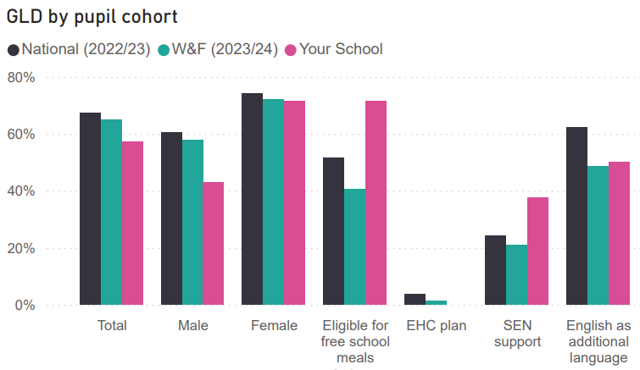
Early Years 2024

Year 1 Phonics 2023 - 2024

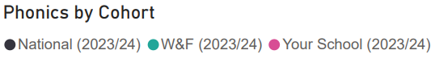
2024
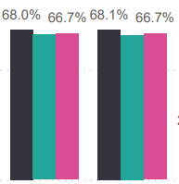

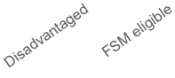

Key Stage 2 SATS Results 2024
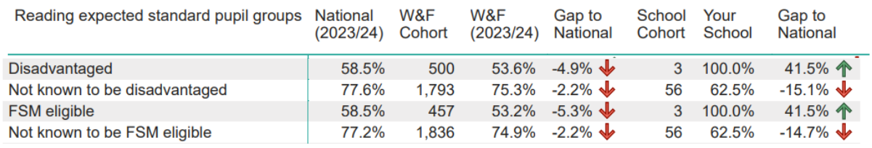
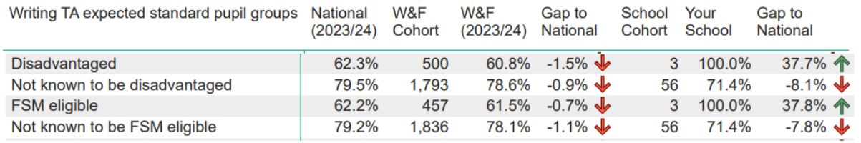
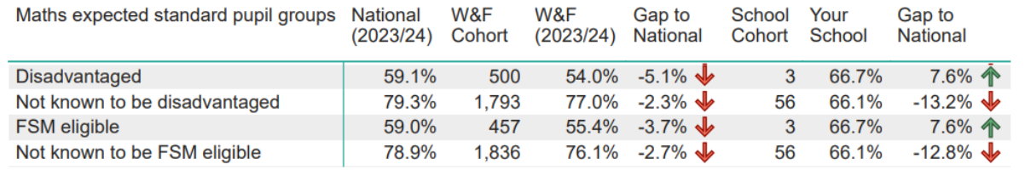
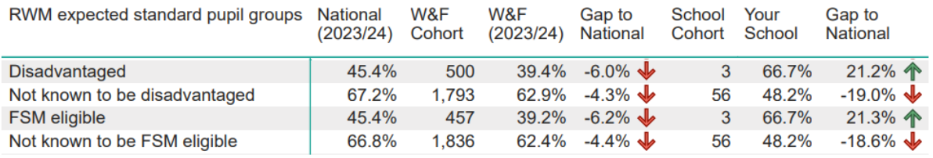
Reading, Writing and Maths combined
Externally provided programmes
Please include the names of any non-DfE programmes that you purchased in the previous academic year. This will help the Department for Education identify which ones are popular in England
Programme | Provider
Externally provided programmes  Programme Provider Young Lives is a specialist consultancy working in partnership with schools and parents to provide flexible and bespoke support to young people on a wide range of health matters: -  ∙ Family issues ∙ Coping with anger, sadness, rejection, isolation, loss or anxiety and associated behavioural issues ∙ Peer pressure and/or friendship issues ∙ Healthy relationships ∙ Personal identity ∙ Improving confidence, self-esteem and emotional wellbeing ∙ Improving communication with professional involved in their care | Young Lives https://younglives.com

