Pupil premium strategy statement 2023/2024
This statement details our school’s use of pupil premium (and recovery premium) funding to help improve the attainment of our disadvantaged pupils.
It outlines our pupil premium strategy, how we intend to spend the funding in this academic year and outcomes for disadvantaged pupils last academic year.

School overview
Detail | Data
School name | Newbarns Primary and Nursery School
Number of pupils in school | 442
Proportion (%) of pupil premium eligible pupils | 10
Academic year/years that our current pupil premium strategy plan covers | 2023-4
Date this statement was published | December 2023
Date on which it will be reviewed | December 2024
Statement authorised by | Gary Birkett
Pupil premium leaders | Gary Birkett, Victoria Fitzgibbons
Governor lead | Elaine Foylan
Funding overview
Detail | Amount
Pupil premium funding allocation this academic year | £75,240
Recovery premium funding allocation this academic year | £6,525
Pupil premium funding carried forward from previous years (enter £0 if not applicable) | £0
Total budget for this academic year  If your school is an academy in a trust that pools this funding, state the amount available to your school this academic year | £78,650

Part A: Pupil premium strategy plan

Statement of intent
The results of the 2013 cohort of children prompted a swift response and additional support is now used very effectively to enhance the quality of learning, progress and attainment of pupils. The progress and attainment of Pupil Premium children is now tracked far more rigorously. We will consider the challenges faced by vulnerable pupils, such as those who have a social worker and young carers. The activity we have outlined in this statement is also intended to support their needs, regardless of whether they are disadvantaged or not. Effective deployment of trained staff has impacted positively on the well-being and emotional development of identified pupils. The success of our deployment of resources will be measured on the progress pupils make, feedback from them, their teachers and families on their emotional wellbeing. Children’s “readiness” to learn has been aided by the investment of the Pupil Premium funding in initiatives such as SERIS (Supporting Emotional Resilience in Schools), Kidsafe and Young Lives. Children learning how to keep themselves safe. Families’ improved relationships, through intervention from Young Lives, has helped overcome the barriers for learning experienced by our disadvantaged pupils. Funding will be used to subsidise residential visits and trips, as well as providing extra-curricular clubs that are free of charge. This will result in all children who wish to take part in visits doing so and the overwhelming majority of children enjoying an after-school activity of some sort. All of this will benefit their resilience and wellbeing, which are major barriers to educational achievement.
Ultimate Objectives
- To narrow the attainment gap between disadvantaged and non-disadvantaged pupil both nationally and within school data.
- To ensure children in receipt of Pupil Premium Funding are given the same extra-curricular opportunities as other pupils.

Challenges

This details the key challenges to achievement that we have identified among our disadvantaged pupils.
Challenge number | Detail of challenge
1 | The main barrier to educational achievement is the lack of emotional resilience in our children and their families, as well as some parents’ difficulties with behaviour at home. We work closely with agencies to address this through our provision.
2 | Assessments, observations and discussions with staff indicate there is a decline in the social skills of our children. They are unable to play together amicably in some cases (due to time spent apart) and lack other skills such as table manners and toileting skills, in our younger children.
3 | Our assessments show a decline in language and communication skills in our younger children.
4 | Lack of enrichment experiences in and outside school due to lack of finances.
5 | Challenging family circumstances – ensuring vulnerable families continue to access the support they need, to ensure their children feel positive and successful.

Intended outcomes
This explains the outcomes we are aiming for by the end of our current strategy plan, and how we will measure whether they have been achieved.
Intended outcome | Success criteria
Children are supported, along with their families, to become more resilient. | - Children can verbalise their feelings and worries. Possible attendance issues are improved.
Children’s emotional literacy skills are improved. | - Children’s termly phonics results show improvements and children who have not passed the phonics screening check in Year 1, are given the extra support they need to improve. Additional STA support for trained ELSA workers have had a positive impact on children’s wellbeing.
Children’s behaviour for learning is improved after being detrimentally affected during lockdowns. | - Children can learn without distraction from outside events and therefore make the progress of which they are capable.
Vulnerable families continue to access the support they need, to ensure their children feel positive and successful. | - Parent surveys/feedback show that parents feel supported by the school.  - Parents accessing appropriate support from outside agencies.

Activity in this academic year
This details how we intend to spend our pupil premium (and recovery premium funding) this academic year to address the challenges listed above.

Teaching (for example, CPD, recruitment and retention)
Budgeted cost: Nil
Activity | Evidence that supports this approach | Challenge number(s) addressed
The Deputy Head will complete training to become an accredited Mental Health Champion. | EEF “Using Your Pupil Premium Funding Effectively.” | 1,2,5

Targeted academic support (for example, tutoring, one-to-one support structured interventions)
Budgeted cost: £60,000
Activity | Evidence that supports this approach | Challenge number(s) addressed
Booster lessons | Education Endowment Foundation: Small Group tuition (low cost, moderate impact) | 1
Additional STA support for phonics teaching focusing on disadvantaged children reaching the expected phonics standard in Year 1 and those who didn’t reach the required standard who are now in Years 2 3 and beyond. | EEF “Using Your Pupil Premium Funding Effectively.” Additional one-to-one and small group tuition in phonics enables children to be taught the letters and sounds they need to know. This results in children knowing more and remembering more in phonics. | 3

Wider strategies (for example, related to attendance, behaviour, wellbeing)
Budgeted cost: £20,225
Activity | Evidence that supports this approach | Challenge number(s) addressed
Funding for attendance at curriculum clubs & residential/school trips | Education Endowment Foundation: Arts/Sports participation (low- moderate cost, moderate impact). | 3, 4
Funding for attendance at breakfast/after school clubs | Education Endowment Foundation: Breakfast Club (low cost, moderate impact – 2017 research) | 5
Funding for school uniform | Education Endowment Foundation: School Uniform (low cost, unclear impact) | 4, 5
Family Liaison Officer/SERIS Worker | Education Endowment Foundation: (moderate impact, moderate cost) | 1, 5
Funding for Young Lives to work with families | Education Endowment Foundation: (moderate impact, moderate cost) | 1, 5

Total budgeted cost: £ 80,225

Part B: Review of outcomes in the previous academic year

Pupil premium strategy outcomes
This details the impact that our pupil premium activity had on pupils in the 2022-3 academic year.
Reading and maths - our assessment of end of Key Stage 2 attainment of disadvantaged pupils shows a decline from the previous set of data, which were in line with non-disadvantaged pupils in school and those nationally as well. Individual case-studies on these 9 children are available. They cannot be detailed here due to the risk of identifying children, as there are so few children involved.
Newbarns Primary and Nursery School Results 2023

Early Years 2023
Children enter our Nursery and Reception classes below age related expectations. The vast majority of children in our Nursery are working at age 22-36 months. At the end of the year, the vast majority of children were working at 30-50 months, showing good progress.
In Reception, the initial baseline showed that children were below expectations for their age. At the end of the year 70.5% achieved GLD (National results are 67.3%). Given children’s starting points on entry to school, excellent progress is evident.
Year 1 Phonics 2023
90.7% (National 78.9%) This trend from 50% eight years ago shows amazing progress. 8 children re-took the check in Year 2 with 1 child reaching the standard.
Key Stage 1 SATS Results 2023
2023 KEY STAGE 1 SATS RESULTS (NATIONAL)  - 68.3% of pupils met the expected standard in reading  - 60.1% of pupils met the expected standard in maths  - 70.4% of pupils met the expected standard in writing | 2023 KEY STAGE 1 SATS RESULTS (NEWBARNS)  - 74.5% of pupils met the expected standard in reading  - 63.6% of pupils met the expected standard in maths  - 86.4% of pupils met the expected standard in writing

Key Stage 2 SATS Results 2023
Subject | Newbarns (Met the expected standard) | National (Met the expected standard)
Reading (Test) | 75.9% | 72.6%
Writing (Teacher Assessment) | 75% | 71.5%
Maths (Test) | 72.2% | 72.9%
Spelling Punctuation and Grammar (Test) | 77.8% | 72%

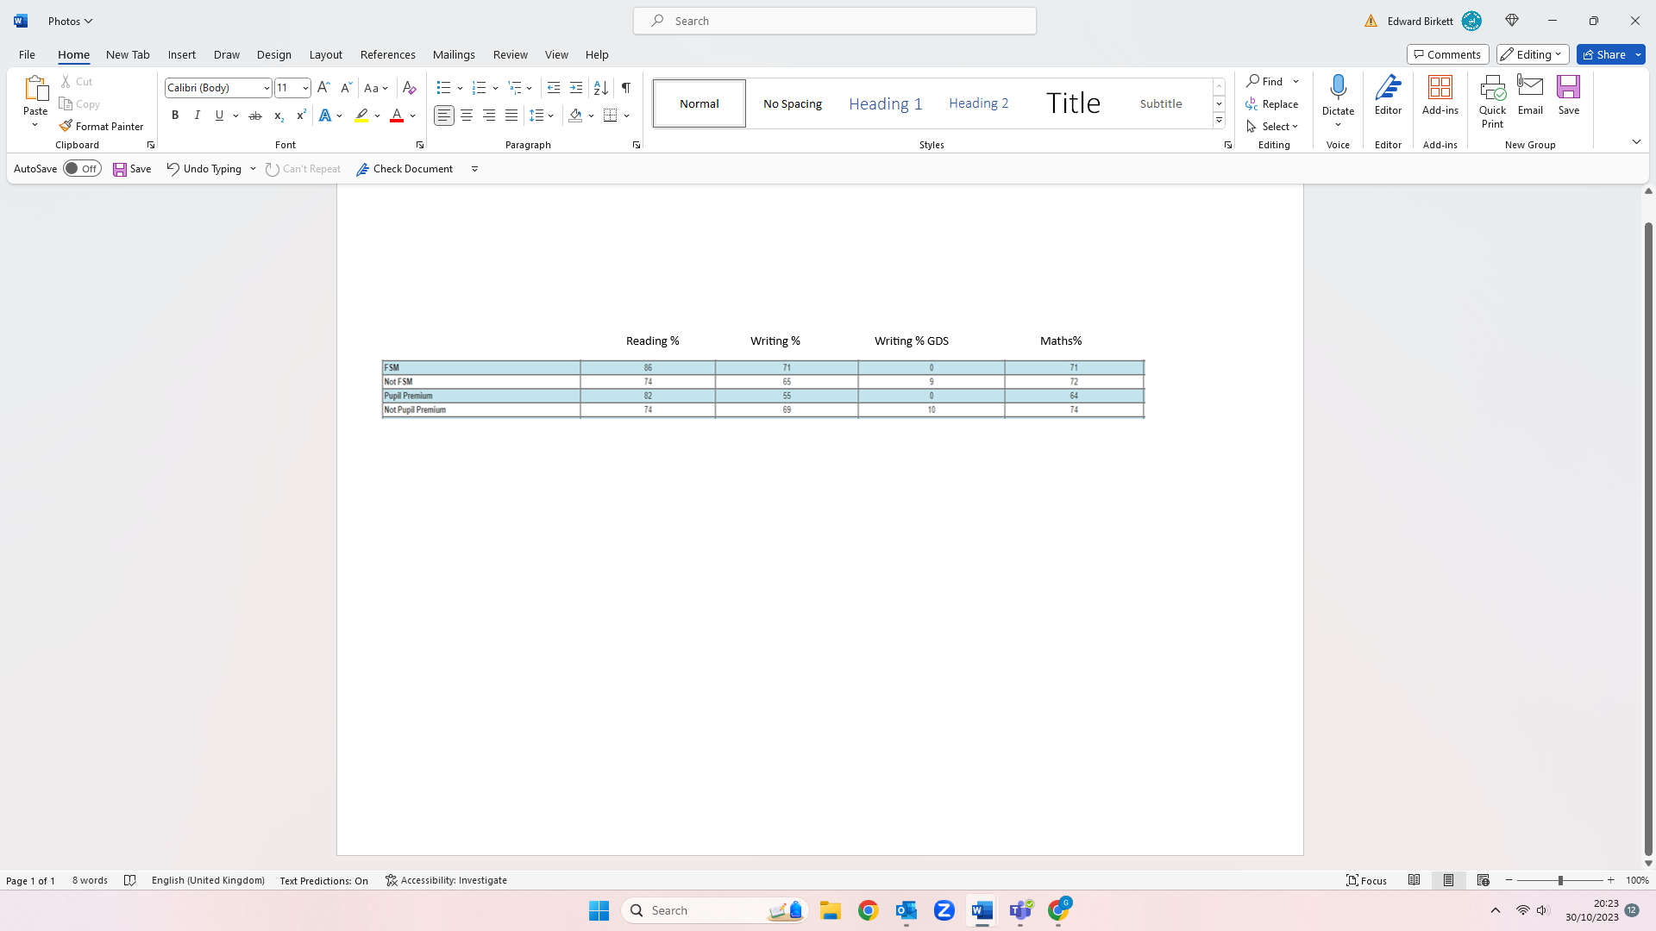
Reading, Writing and Maths combined – 64.2% (National – 59%)

Externally provided programmes
Please include the names of any non-DfE programmes that you purchased in the previous academic year. This will help the Department for Education identify which ones are popular in England
Programme | Provider
Externally provided programmes  Programme Provider Young Lives is a specialist consultancy working in partnership with schools and parents to provide flexible and bespoke support to young people on a wide range of health matters: -  • Family issues • Coping with anger, sadness, rejection, isolation, loss or anxiety and associated behavioural issues • Peer pressure and/or friendship issues • Healthy relationships • Personal identity • Improving confidence, self-esteem and emotional wellbeing • Improving communication with professional involved in their care | Young Lives https://younglives.com

